| **Exp no:5** | **Half wave rectifier and full wave rectifier** |
| --- | --- |
| **Date:10-11-2021** |

**Aim:**

1. To set up a half wave rectifier and to find the dc value of rectified voltage
2. To set up a full wave rectifier and to find the dc value of rectified voltage

**Apparatus:**

LT Spice software tool

**Circuit diagram:**

**Procedure:**

**Model graph:**

**Note: Draw hand drawn diagrams in your notebook.**

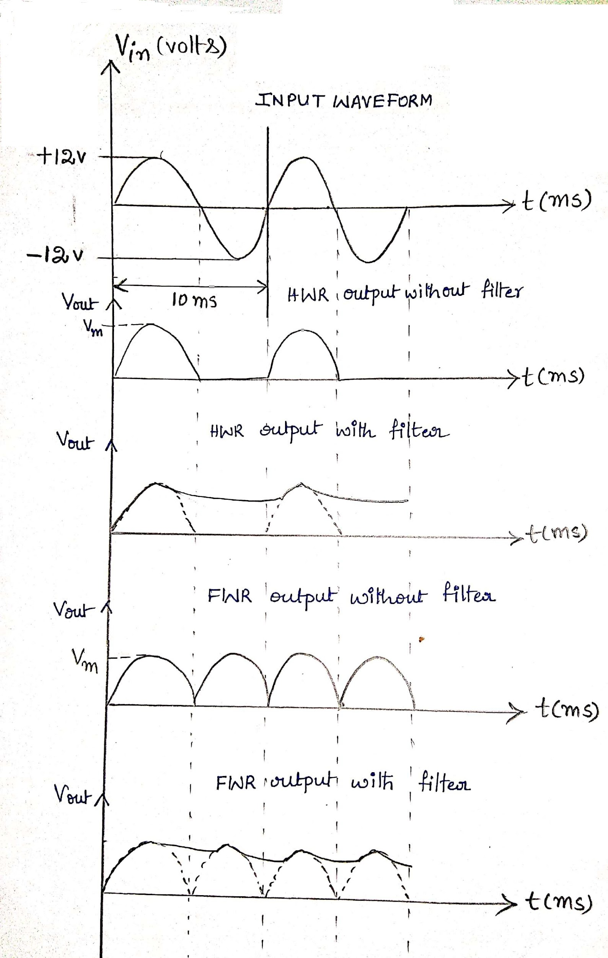

**Calculations:**

**For half wave rectifier:**

Vm=11.3V (From simulated output of HWR)

Vdc=

Vrms=

Ripple factor =

**For fullwave rectifier:**

Vm=11.3V (From simulated output of FWR)

Vdc=

Vrms=

Ripple factor =

**Comparison of theoretical with simulated values:**

|  | Theoretical value | Simulated value |
| --- | --- | --- |
| Ripple factor for HWR | 1.21 | 1.21 |
| Ripple factor for FWR | 0.48 | 0.48 |

**Result:**

The half-wave and full-wave rectified outputs are simulated successfully

Inferences:

1. The theoretical value of ripple factor for half-wave rectifier is same as simulated value
2. The theoretical value of ripple factor for full-wave rectifier is same as simulated value
3. The amplitude of the rectified output is reduced when the capacitor is connected to the resistor. Hence the ripple factor can be reduced with a filter.